GENETICS REVISION

- Tommy, Chuckie, Susie and Angelica are childhood friends who are now adults. Tommy is married to Susie, and Chuckie is married to Angelica. Use the information below to determine the answers to each question about any children that these two couples may have in the future.
- For each genotype below, indicate whether it is a heterozygous (He) or homozygous (Ho) genotype.
SS .......... Bb .......... NN .......... Ff .......... ss .......... nn ..........
Nn .......... ff .......... Ss .......... bb .......... BB.......... FF ..........
- Determine the phenotype for each genotype using the information provided about Chuckie.
- Straight hair is dominant to curly/wavy hair.
SS ................................... Ss ...................................... ss ......................................
- Freckles are dominant to no freckles.
FF .................................... Ff ...................................... ff ......................................
- For each phenotype, give the genotypes using the information provided about Angelica.
- No glasses (N) is dominant to needs glasses (n).
No glasses = ..................................... Needs glasses = .......................................
- Blonde (B) is dominant to not blonde (b).
Blonde = ........................................ Not blonde = ........................................

- Tommy is heterozygous for straight hair while Susie is homozygous for curly hair.
- Complete the Punnett square below to show the possibilities that would result if Tommy and Susie had children.
 |  | Tommy
 |  | S | s
Susie | s
Susie | s

- List the possible genotypes and phenotypes for their children.
....................................................................................................................................

What are the chances of a child with straight hair?
....................................................................................................................................

What are the chances of a child with curly hair?
....................................................................................................................................

- Angelica does not need glasses but she is heterozygous (Nn) for this trait. Her husband, Chuckie, needs glasses (nn).

- Draw a Punnett square below to show the possibilities that would result if Angelica and Chuckie had children.

- List the possible genotypes and phenotypes for their children.
....................................................................................................................................

What are the chances of a child who needs glasses?
....................................................................................................................................

What are the chances of a child who does not need glasses?
....................................................................................................................................

- Use the Pickles family pedigree below to answer the following question about the inheritance of ABO blood groups in this family.
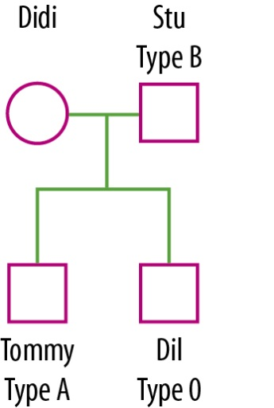

What is Didi’s blood type and genotype? Give a reason for your answer.
....................................................................................................................................................................................................................................................................................
..........................................................................................................................................
....................................................................................................................................................................................................................................................................................
..........................................................................................................................................

- Scott is a high school student who thinks he is a werewolf. Eventually Scott discovers that he was misdiagnosed and is not actually a werewolf, but suffers from hypertichosis (werewolf syndrome), an X-linked dominant disease. Scott knows his biological father also suffered from the disease, but he does not know if his biological mother was affected by it because she passed away soon after he was born.
- Referring to the pedigree chart below, explain why Scott had the disease but his brother did not.
....................................................................................................................................................................................................................................................................................
..........................................................................................................................................
....................................................................................................................................................................................................................................................................................
..........................................................................................................................................

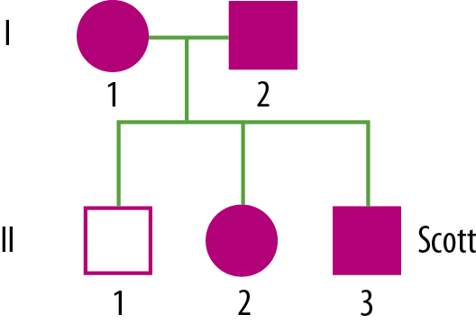

- Complete the following Punnett square then explain why you would not expect all of Scott’s children to have the disease if he married a woman unaffected by the disease.
....................................................................................................................................................................................................................................................................................
..........................................................................................................................................
....................................................................................................................................................................................................................................................................................
..........................................................................................................................................

 |  | Scott
 |  | X^{W} | Y
Female partner | X^{w}
Female partner | X^{w}

- Complete the following table comparing mitosis and meiosis in humans. Some information has been filled in for you.
 | Mitosis | Meiosis
No. of cell divisions |  | 2
No. of DNA replications |  | 1
No. of daughter cells produced | 2
No. of chromosomes in parent cell |  | 46
No. of chromosomes in daughter cells |  | 23
For growth and development? (Yes/No) |  | No
For reproduction? (Yes/No) | No

- Use the listed words to complete the sentences.
amino | chromosomes | diploid | dominant | errors | forensic
gametes | generation | genetics | genotypes | guanine | helix
identical | meiosis | nitrogen | opposite | physical | replicate
two
1. The ........................ of cells contains genes made of DNA.
2. Genes determine many ........................... characteristics (e.g. eye colour).
3. Diploid human cells contain 23 chromosomal pairs. ......................... cells, however, contain only 23 chromosomes.
4. In a DNA molecule the amounts of thymine and adenine are always the same, and the amount of cytosine and ....................... are always the same.
5. The Watson–Crick DNA model is a double ...................... like a twisted ladder.
6. Each step of the DNA helixW is made up of two ........................... bases and the bases are attached to the sugar units that are part of the sides of the ladder.
7. The steps of the DNA helix are composed of paired nitrogen bases. There is always an adenine base ........................ a thymine base and a cytosine base opposite a guanine base.
8. Polypeptides are made up of units called ............................ acids. A set of three DNA bases codes for a particular amino acid.
9. During cell division (mitosis) the DNA needs to ............................... to ensure the new cells have identical copies of the DNA.
10. In most instances the DNA is copied exactly during mitosis. In some cases ........................ occur and mutations result.
11. Gametes are formed by a type of cell division called ..........................................
12. The fertilised egg has a ...................... number of chromosomes.
13. X and Y are the sex chromosomes. Females have ................... X chromosomes and males have an X and a Y chromosome.
14. Different forms of a gene are called alleles. Alleles can be ............................... or recessive. Two copies of a recessive gene are required for the characteristic to be expressed.
15. Gregor Mendel was an Austrian monk who conducted the first quantitative .......................... experiments using garden peas.
16. Punnett squares are a useful tool to predict the proportion of .......................... and phenotypes in the offspring.
17. Pedigree diagrams are useful in showing how various genes are transferred from one ......................... to another.
18. DNA fingerprinting is used in ............................ investigations and paternity tests.
19. Clones are organisms that are genetically ..........................

